Science Fair Requirements and Board Layout
Required Elements and Placement
- Title – Catchy but accurate
- Abstract – Summary of the experiment and findings (write last!)
- Question – What is the problem you are trying to answer?
- Hypothesis – Your answer to the problem, in good format
- Background Research – What is known about this problem already, and what do you need to know to perform the experiment?
- Materials – List of all things needed to conduct experiment
- Procedure – Step by step of what was done in each trial
- Conclusion: summary of what you found out in your experiment, focusing on your observations, data table, and graph(s), which should be included at this location in the report. It also summarizes how your results support or contradict your original hypothesis
Optional Pieces
- Future Directions of Project – what could be your next step, where would you take this project next?
- Photos/Experimental Display

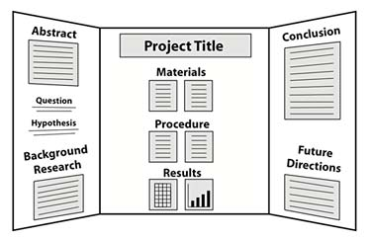
Science Board Layout (Suggestion)

