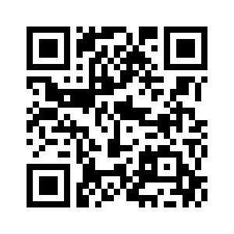
Biology Syllabus
2019-2020 School Year
Instructor: Mrs. Samantha Hall
Education: B.S. Unified Science Education from Hannibal LaGrange University
Scan this QR code to access Mrs. Hall’s website.
Contact: Email: shall@mcr4.k12.mo.us
Phone: (660) 226-5615 (School office)
Website: shallscience.weebly.com

Remind code: enter @93bf8g to 81010 OR send questions to 93bf8g@mail.remind.com

**If you have a question for me regarding homework or class matters after school, you may send me an email. You may also start a chat with me on Remind. I am not promising that I will always be able to answer your questions, but I will do my best to help you. The BEST way to get help is to find me at school; either before/ after school or between classes. Do not put off your work! It will allow you to get help on questions before you go home, but I understand there will be times when this won’t be possible.

Course Objectives: Throughout the course of the year, students will be examining the concepts of basic biology, including Cell Theory, structure of a cell, cellular reproduction and processes, basic genetics, history of biology and biological diversity, and ecology.

Prerequisites: None

Course Outline: This outline is approximate and is subject to change.

SEMESTER 1
  - The Microscope
  - Unit 2: The Cell
  - Unit 3: Genetics

SEMESTER 2
  - Unit 3: Genetics
  - Unit 4: History of Biological Diversity
  - Unit 1: Ecology

Materials: Students should have the following materials with them each day:

- Pencils
- Grading Pen (any color but yellow or black)
- 3-Ring Binder (2” or 2 ½”)
- 2 Packs Loose Leaf Notebook Paper
- Textbook
- Scientific Calculator (NOT graphing!)

Grading:
The grades you earn will be given based on the following guideline and scale...
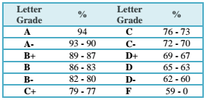
    - Homework – 20%
    - Quizzes and Tests – 40%
    - Labs/Projects- 20%
    - Article Reviews – 10%
    - Semester Cumulative Final – 10%

Extra Credit: There may be opportunities to earn extra credit throughout the school year. These opportunities may come in the form of donated materials for labs, extra work, or extra participation. These opportunities will be ONLY assigned by the teacher. Extra credit WILL NOT be offered to individual students who ask, only to the entire class and on an equal opportunity basis.

Finals: All students will be taking two cumulative finals; one at the end of each semester. These finals will test understanding of all information that was covered in that semester. Know that it is not guaranteed that every piece of information will actually appear on the test. Students should not put off studying until the week before, but should maintain understanding of material covered throughout the course. Study materials can include your textbook, your notes, and your completed study guide.

Homework and Late Work: This course will demand your full participation in assigned work. Homework is given because it helps you practice what you are learning. All assignments are due at the time the teacher asks for them. Any assignments that are turned in after the work is asked for are considered late. Late assignments may be turned in the next day by class time for a 10% deduction with a late pass. Assignments turned in any time after will receive a Zero Hour. Two late passes will be given each quarter. Not using a late pass can result in extra credit at the end of that quarter

Assignment Requirements: Students are expected to read and follow directions on any assignment given. Students are expected to use their text and note resources before asking the teacher or a classmate. Students are responsible for checking the board each day for assignments. (Please note: If a student misses class for ANY reason, the student is responsible for getting all assignments in order to avoid receiving a late penalty).

Cheating and Plagiarism: Cheating and plagiarism will NOT be tolerated from any student. Any attempt of a student to copy work that is not their own will result in a ZERO (0%) for the assignment and a discussion with the student(s). This includes COPYING from another student, from the textbook, an Internet source, or any other work that was not their own. Everything should ALWAYS be written in your OWN words.

YOUR FIRST ASSIGNMENT: Get a 3-ring binder and put your science stuff in it (including this signed syllabus). Due Monday, August 26, 2018. This assignment is worth 10 points.

I have read and understand this syllabus, and I agree to follow all rules and regulations discussed, and most importantly, to have fun and learn a lot about science!!!

Signature______________________________________________________ Date_______________

